HOW TO TAKE YOUR TEMPERATURE USING A DIGITAL THERMOMETER
- Read the instructions that came with the thermometer
- Wash your hands with soap and warm water before using the thermometer.
- Clean the thermometer before and after each use with soap and lukewarm water.
- Don't use the same thermometer for both oral and rectal temperatures. Get two and label which is used where.
- Wait at least 6 hours after taking medications that can lower your temperature, like acetaminophen (Tylenol, others), ibuprofen (Advil, Motrin IB, others) or aspirin.
- If you've been eating or drinking, wait 30 minutes before you take a temperature by mouth

Oral temperature: You'll need an oral thermometer, used in the mouth.
- Turn on the digital thermometer. Place the thermometer tip under your tongue.
- Close your mouth around the thermometer for the recommended amount of time or until the thermometer beep indicates it's done.
- Remove the thermometer and read the number.
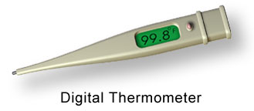
Source: newsnetwork.mayoclinic.org 2020

